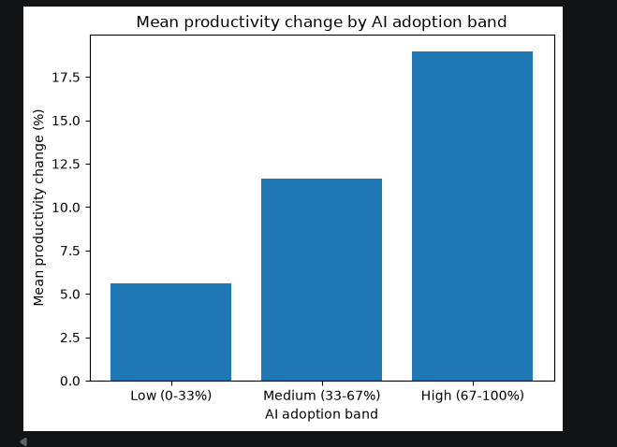

Why a bar chart is the appropriate chart
A bar chart is the right choice here because adoption_band is categorical (Low/Medium/High) once you bucket the continuous ai_adoption_rate, and you're comparing one summary number (mean productivity change) across those categories. Bar charts are built for exactly that — comparing a single aggregated value across a small number of groups.
Why it's important / what it adds
The scatter plot shows the raw relationship point-by-point, which is powerful but noisy with 150,000 dots. This chart strips the noise away and answers the same question in one glance: "does average productivity change actually step up as adoption increases?" It's a simplified, easy-to-read companion to the scatter plot rather than a replacement for it.
What it shows
A clear, near step-wise increase: Low adoption companies average ~5.6% productivity change, Medium ~11.6%, High ~19%. The gap between each band is roughly similar in size, which suggests the relationship isn't just "some effect" but a fairly consistent, monotonic one — every step up in adoption tier corresponds to a real step up in average productivity gain.
What the rubric wants beyond the plot
Task 4 wants you to go past "here's the chart" into interpretation. For this one, that means:
- State the actual numbers (5.6% → 11.6% → 19.0%) rather than just describing the shape
- Note that this is a derived/grouped view of the same two focus variables, not a new variable — this keeps your report consistent with the "single comparison" framing your lecturer asked for
- Acknowledge the limitation: a bar chart only shows the mean per group, so it hides the spread within each band — pair this description with what the boxplot/scatter already showed to give the full picture, rather than treating this chart as evidence on its own

